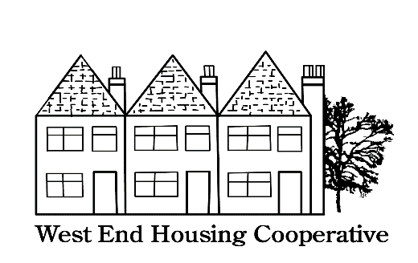
Registered Office
2 Wellesley Terrace
Fenham
Newcastle upon Tyne
NE4 5NL
Tel: - 0191 2736418
Email: - wehousing@googlemail.com

Application form for West End Housing Co-op Tenancy and Membership

Name of applicant applying for tenancy

Date of birth

Current address of applicant
Post code

Contact information
MOBILE:

LAND LINE:

EMAIL ADDRESS:

National Insurance Number or details of permission to reside in the UK. (Required by law)

Where did you hear about this vacancy?

Do you know any current/previous member of the West End Housing Co-op?
YES/NO

Could you please give details of the members name(s) and your relationship with them

Please give the name and address of your current landlord

Name and age of occupants currently living at the address and relationship to you:

NAME | AGE | Relationship | Gender | Moving with you (y)

Please give us some information about your current accommodation
Is your home:
Council  YES/NO | Private  YES/NO | Rented  YES/NO | OTHER: …...........................................................

Type
Flat  YES/NO | House  YES/NO | bungalow  YES/NO | OTHER: …............................................................

Number of rooms
Bedroom | Kitchen | Lounge | W.C. | Bathroom | Dining | Other

YES/NO
If yes, why:

Has your landlord started proceedings to evict you? YES/NO
Are you about to be made homeless?

Are you overcrowded?
YES/NO
If yes, how:

Is the property in bad repair?
YES/NO
If yes, how:

How much notice must you give (if any) at your current dwelling?

Do you suffer any health problems which make living in your current accommodation difficult?
YES/NO
If yes, how:

Is there anything you wish to mention about your current accommodation that may assist your application – eg harassment?

Have you made any other attempts to gain housing?
YES/NO
If yes, where/how:

Are you registered with YHN for housing?
YES/NO
If yes, for how long:

Do you have a priority level:

Can the Housing Co-op check your rent card/paying record if required?
YES/NO

If no, why:

Can the Housing Co-op carry out a house visit at your current accommodation if required?
YES/NO
If yes, why:

Do you and/or your spouse/partner own a house or property which you treat as your main dwelling (home)?
YES/NO
If yes, give details:

Do you and/or your spouse/partner own a house or property other than the house or property you treat as your main dwelling?
YES/NO
If yes, give details:

Have you directly or indirectly transferred a house or property in the last twelve months to another person, not at full value or by way of a gift?

YES/NO
If yes, give details:

Any additional comments you would like to add

Please list your addresses over the past five years including dates and landlords’ contact details.

The following information is needed only to enable the co-op to assess risks to the co-op in terms of safety and financial security. Do you have any criminal convictions? There is however NO NEED to mention 'spent' convictions.

Do you have any pets that would move with you?

What attracts you to living in a Housing Co-op?

As far as I know, the answers I have given on this form are true. I understand that I may lose any housing or tenancy if I have given false information. I understand that all the information I have given will be put on the landlord’s computer. I will tell the Housing Co-op immediately if there is any change to the circumstances I have told you about in this form. I understand that by signing this declaration I am giving permission to contact any previous landlords and relevant agencies to check the information and release any relevant information. I agree to the information provided being shared with other housing agencies.

Sign

Print Name

Date

Data Protection Act

We store the information you give us on your housing application form in line with the General Data Protection Regulations 2017. We may share the information with other landlords or ask for references from your previous landlords. It is important that the information you give us is accurate. We may use certain information on your form to check the accuracy with the department of Work and Pensions, Police, Probation and Social Services ( i.e.Supported Living and the Homelessness team) and other registered social landlords and private landlords or their agents.

In completing this form, you understand that in order to process your application we may share information you have provided with all the agencies identified mentioned within this application. All information which you have provided is processed in accordance with the GDPR 2017 and the obligations which are placed on Data Controllers

Please return this form to wehousing@googlemail.com
This form was updated in April 2024.

The West End Housing Cooperative is registered with the Financial Conduct Authority. Register Number 22789R

